# Lab 17

Instructor: Sidra Khatoon E-mail: skhatoon[@uitu.edu](mailto:ad@uit.edu).pk

# Objective

# The objective of lab is create a shopping cart app using Provider(Part 2)

# .

**Student Information**

|  |  |
| --- | --- |
| **Student Name** |  |
| **Student ID** |  |
| **Date** |  |

**Assessment**

|  |  |
| --- | --- |
| **Marks Obtained** |  |
| **Remarks** |  |
| **Signature** |  |

# Objective

# The objective of lab is create a shopping cart app using Provider(Part 2)

# Instructions

You have to perform the following tasks yourselves. Raise your hand if you face any difficulty in understanding and solving these tasks. **Plagiarism** is an abhorrent practice and you should not engage in it.

# How to Submit?

Submit lab work using Teams.

# Shopping Cart App using Provider:

The app has two separate screens: a catalog, and a cart (represented by the MyCatalog, and MyCart

widgets, respectively). It could be a shopping app, but you can imagine the same structure in a

simple social networking app (replace catalog for "wall" and cart for "favorites").

The catalog screen includes a custom app bar (MyAppBar) and a scrolling view of many list items (MyListItems).

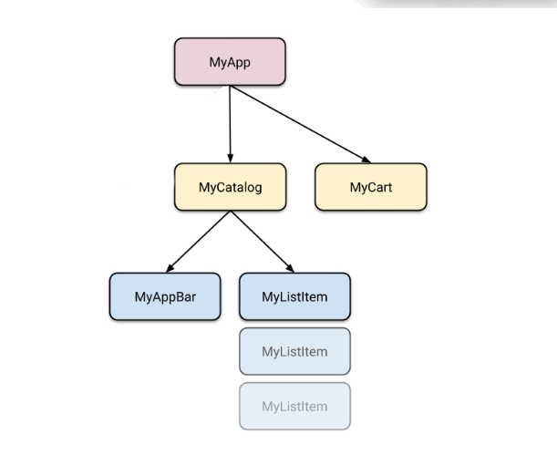

**Now we start creating our UI for Catalog Screen**

**Now we start creating create of list item**

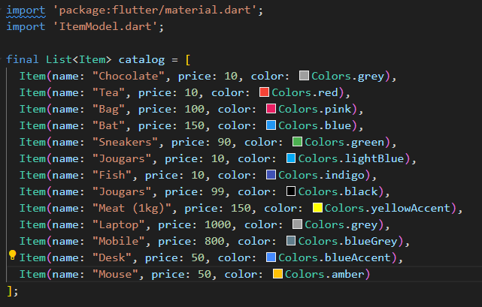

**Now we start updating our list in catalog screen with our list item.**

**Update this code both screen. Also update the item widget code.**

**Now we move to the main part of the app which is state management. Now we update the code of provider class.**

Now add the change notifier class in the main.dart file to access provider class.

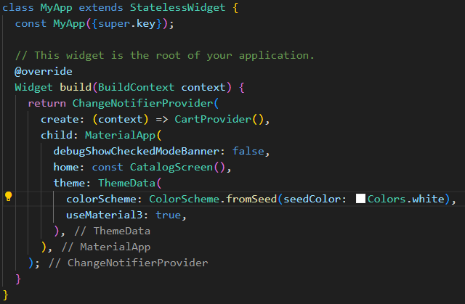

Now we want to remove button from the cart screen we set bool value for isCartitem.

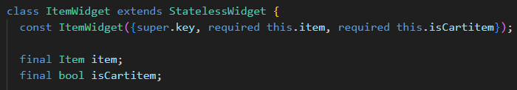

Now set isCartitem to true in cart screen and isCartItem false in catalogScreen.

# Assessment:

Create a shopping cart app by using provider along with login page and splash Screen. Use text editor controller to show user name on the top of Catalog Screen.

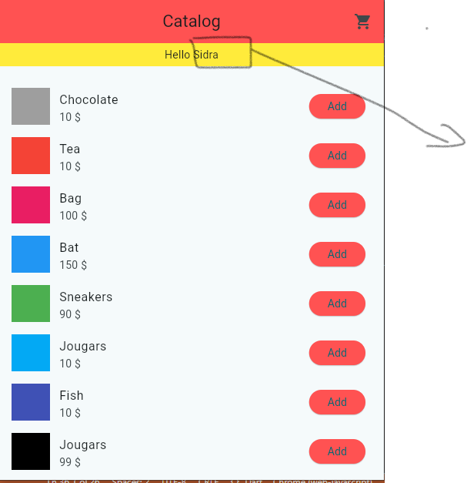

This name is taken form user input field